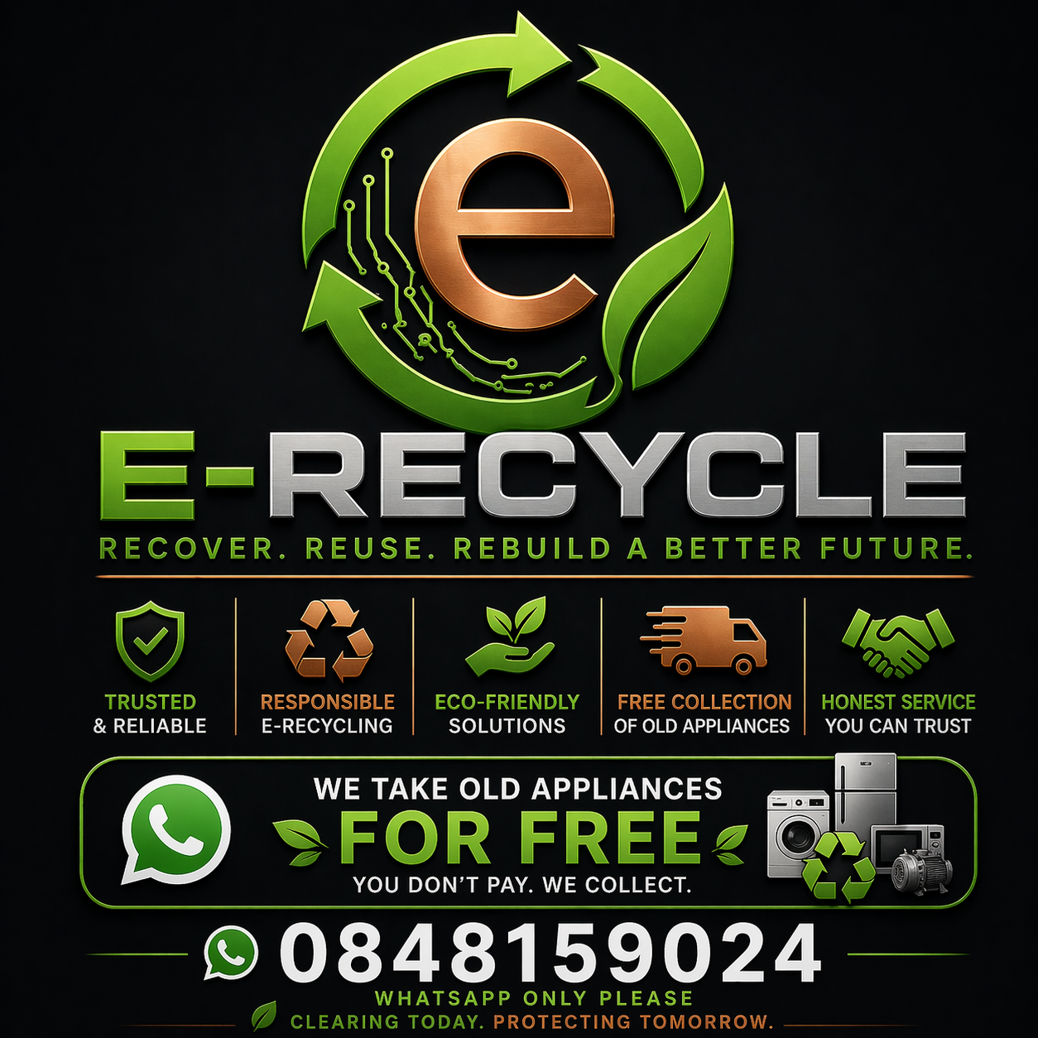
Got old or broken appliances taking up space?
We’ll collect them for FREE — no hassle, no lifting.
To book your pickup, just reply with your details by clicking the link at the bottom and add your:
- Name
- Phone Number
- Address
- Appliance(s) to collect
- Preferred time
👉 We’ll confirm and arrange collection ASAP. Limited daily slots!!
https://wa.link/0nxoyz

